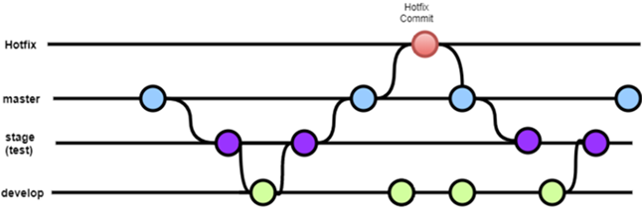

Branch descriptions:

* **Master**: default branch in devops. This branch should be locked and changes should be merged to this branch only with approvals.
* **stage**: This branch contains changes to be tested. Usually used by QA teams so only stabilized versions can be pushed into master. This is not essential but provides better boundaries from development changes.
* **develop** : main branch for development where all changes are merged from feature branches based on release timelines.
* **hotfix**: Use this branch during migration and stabilization period to test fixes and deploy in production. hotfix branch is short lived and only merged to master when stabilized. These changes should be pushed back from master to stage and develop.

Tags: When the deployed software is stabilized, create tag to separate artifacts and rollback your software to stabilized version if current migration fails.

Feature branching strategy:

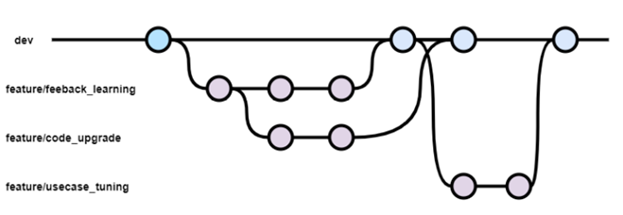

* feature branches are created from latest commit in dev branches.
* branch naming strategy can be decided by the development team
  + our team is following strategy of feature/<feature name>
  + other naming examples,
    - feature/<feature_name_release_date> e.g. feature/code_upgrade_2021_06_01
    - feature/<usecase_story_name> e.g. feature/INT-1001
* Feature branches can be merged to develop branch based on what should be tested and released to production.

final repository branches (example):

